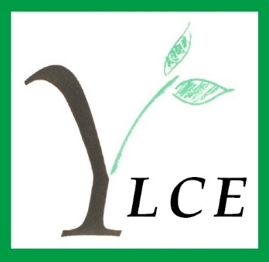

Spring Update 2016

To all our members

I am happy to be taking over as new chair of the Executive Committee, though following Nancy's 20 years of devoted service is a tall order. Her continuing support is much appreciated as is that of the Executive Committee, a most supportive, helpful and knowledgeable group of good women. Phillida as Secretary makes the chair's life much easier; thank you very much Phillida!

Thanks also to those of you who came to the AGM this year and I very much hope to see even more of you attending next year. We transact the necessary business, enjoy a very fine lunch indeed, have a chance to chat and then listen to a speaker. It's a good day. I spoke at the AGM about the very real need to fundraise for the YLCE and to recruit new members and am pleased to report that several members have given feedback.

Please do consider keeping in touch during the year; my contact details are below and it would be good to receive any comments from you concerning what we do, what we don't do and what you think we should do. I will always try to respond and will, of course, pass on your comments to the Executive Committee.

We look forward to the traditional events organised by our Social and Projects Committees and the Forest Hill House Committee (more details elsewhere in this newsletter) - I thoroughly enjoyed the first one, the coffee morning on the 17th of March - and I did win a raffle prize! Many people put a lot of effort into these events and we applaud them for it.

We are hoping to offer extra events during the course of the year. For example, our patron, Lady Halifax, has very generously offered to host us at her home, Garrowby Hall, on Wednesday July 6th. Please do support this and invite family and friends. It is a unique opportunity as the house is not generally open to visitors; it is an excellent fundraising opportunity for us and also an opportunity to recruit new members. Full details of this event are on page 3 of this newsletter and a separate reply form is enclosed (blue insert)

My best regards to you all

Gill

Gill Lydon
Chairman

tel: 0113 2785596 mob: 07940 539360 email: gillian_lydon@hotmail.com

AWARDS COMMITTEE
When the envelopes of applications fell onto our doormats in January, the dull thud was less disturbingly heavy than it had been in September: only 23 this time and not the 70 we’d considered in the previous meeting. (Not forgetting the 112 we’d looked at last June.) March was more demanding of our time: we had 42 applications to evaluate before the meeting, but it still felt like a bit of a holiday. In those two meetings we were able to give 25 deserving women an award to help pay the fees for the courses they had chosen.

As avid readers will remember, we described in the last Newsletter the criteria we use to determine (after sometimes heart-searching deliberation) which of the applicants we decide to support. We were impressed by the commitment to their studies shown by the women we chose and the persuasiveness with which they were able to present their case.

We are supporting a PhD student in Psychology whose own autism was diagnosed only during her undergraduate degree. She is working on the problem of why females are less likely than males to be diagnosed as suffering from the condition in its many forms, or at least diagnosed much later than their male counterparts. Could the girls be covering up their impairments by learning to mimic others socially? She has devised a scale to measure this which is now in the process of being published.

We are also supporting a really well-motivated young woman who currently works within the Asylum decision-making operations of the Home Office and is totally appalled by the Human Resources policies in place. She will begin a part-time MA in Human Resource Management in September, and thus armed she fully intends to transform the department from within. We’d like a fly-on-the-wall camera.

And we continue to be asked for help from aspiring musicians. We know that to get anywhere in the profession they need expensive Masters training. We are helping a 29-year-old complete her Opera training. Her first degree was in English and Drama; she then became a professional actress performing impressive roles in impressive venues. Completing her Masters in Opera Performance, and so refining and developing her singing technique, will make her a very employable prospect for opera companies.

As you see, it’s the women who can put their case in a persuasive way who are successful in gaining our support. And if their personal circumstances attract a particular sympathy, then we give them our unanimous thumbs-up. One such is a young woman who has had to resign from a potentially high-powered job as a support geo-scientist in the software division of energy services consultancy in Scotland. She’s been asked to return to the family farm to help her sick father run the business and eventually take the reins. She can’t possibly give up her interest in Geology she says – she got a high First at Edinburgh – and by doing a part-time Masters in Engineering Geology she will be able to nurture and develop that interest, give herself greater security, and it may well allow her to diversify the family business. (Not by allowing fracking, we assume!)

As always we’ve been thanked profusely for the small contributions we’ve been able to make to the huge fees that are being demanded. The star thank-you letter recently came from the young woman we are supporting through a theatre property-making course at RADA. It came with an intriguing little box. Inside, most carefully wrapped, was a luscious-looking, saliva-inducing red cherry. Yes, you’ve guessed: a handcrafted stage prop - not to be eaten.

However, the Awards Committee is only the channel for the thanks which come to you, the members of the YLCE, who by your support, donations, not to mention astute investments, are able to finance these awards.

(But the cherry stays with us.) Gillie Andrews
GARROWBY HALL
Wednesday 6 July 2016

LADY HALIFAX
invites members of the Yorkshire Ladies’ Council of Education, their families, friends and prospective members to visit her home
GARROWBY HALL
on the afternoon of Wednesday, 6th July, 2016.

Lady Halifax has very kindly invited us to visit her home Garrowby Hall, on Wednesday 6 July at 2pm.
The afternoon will include:
- Afternoon Tea with a glass of champagne in the gardens (inside if cold!)

- A guided tour of the family paintings by Lord Halifax, including the collection of 9 Stubbs, Old Masters and Family Portraits. As these paintings are privately owned, this really is a unique opportunity.

- Displays of lovely family china as we walk round.

- Access to grounds and gardens, Lady Halifax's own garden and her hens (if amenable!)
Above all, the afternoon will be a happy day in good company, offering us a real chance to meet our friends and recruit new members. Please do invite prospective members. We will provide an informative leaflet about the YLCE and, of course, explain that we are fine women and do good work!
Garrowby is five miles outside Stamford Bridge and about an hour’s drive from Leeds. We would however advise that you allow more time in order to negotiate the long driveway, park cars and be ready for Lady Halifax's formal welcome at 2pm. There is room to park 45 cars (more if the weather is fine and we can park on the grass). In order to manage the parking at Garrowby, please indicate on the reply form how many cars you will be bringing, whether you can double up with anyone else you know is coming, and if you could offer a lift to others? Parking is very close to the house, wheelchair ramps can be provided and, as we will be on the ground floor, it's easy both to move around and to sit down when tired.
The cost of the afternoon is £25 each.
Please return the reply slip if you would like to join us on this great occasion. Please contact Gill Lydon or Phillida Richardson if you need any further information.
ALL MONEY RAISED ON THIS OCCASION WILL GO TO THE AWARDS FUND.

FOREST HILL

In November 2015 Mrs Jocelyn Jones resigned from the House Committee having served for about 10 years. She was thanked for all her hard work and support throughout that time. Mrs Chris Turney and Mrs Valerie Wood-Robinson have been welcomed on to the committee and attended their first meeting at the beginning of March.

Over the past few months there have been several vacant flats but three of these have now been let and will be occupied very shortly. As at the beginning of April there will be two flats available to let and it is hoped they will soon be filled.

During February the vestibule by the front door, the dining room and the lounge were re-decorated and new curtains and blinds were fitted in the lounge. It is planned to re-decorate the hall landing and stairs to both floors in the autumn.

A new gardener has been appointed and it is hoped the ground will dry out very soon so that he can start cutting the grass and tidy up the winter debris.

In December Lorraine Green, the cook, left Forest Hill to take up a post at St Gemma’s Hospice. She needed to work for more hours than Forest Hill was able to give her. Tess Watach and her staff are managing the day to day running of the house and kitchen without a cook very successfully. The number of residents taking lunch varies greatly.

During December the residents were entertained by a group of clarinet players and the Beavers from St Edmund’s Church sang carols. Tess worked over Christmas Day and Boxing Day and provided lunch for those who stayed at Forest Hill over the holiday.

At the beginning of March the House Committee gave a tea party for the residents. It was well attended and the home baking was very much appreciated. The Annual Garden Party will take place on Thursday 16 June 2016 and will be opened by the Reverend David Pickering, the Minister at St Andrew’s United Reform Church.

Patricia Hollis

PROJECTS COMMITTEE
This year the Projects’ Committee has continued to support the extra needs teacher at The Inside Outside Club, St Gregory’s, Seacroft. Seacroft is one of the most deprived areas of Leeds and Inside Outside Childcare offers valuable educational and practical support for children of school age as well as their parents.
We held our annual fundraising Coffee Morning on Thursday 17th March at St Chad’s Parish Centre, Otley Road, Headingley. Our guests enjoyed coffee and biscuits and the opportunity to browse and purchase cakes and home-made produce, bulbs and plants, cards, CDs and good quality second hand books. Thanks to the generosity of all our supporters, we raised nearly £600. Grateful thanks are due to the caretaking staff of St Chad’s Parish Centre as well as to all the kind volunteers from outside our committee who helped to make the morning such a success.
Margaret Pullan

AGM
The AGM this year was a momentous occasion as it marked the resignation of Nancy Donner as Chairman of the Executive Committee and Mary Herbert from the Executive Committee.
Nancy had been Chairman for over twenty years and Mary Herbert paid tribute to the hard work and all the time that she had dedicated to YLCE. Nancy has seen many changes through her time in office as Chairman and has guided the Council well. Her enthusiasm, attention to detail and energy has been tremendous and we are delighted that she remains an active member of the Charity.
Mary Herbert has also given phenomenal support to YLCE, serving on the Executive Committee for over 30 years. Mary has always been interested in all aspects of YLCE and has shared her wisdom, always steering us in the right direction. We look forward to her continued help, advice and friendship as a member of the Council.
The AGM also saw two of our previous Award recipients give talks on their studies and careers. Both were extremely hard working, enterprising and deserving students. Their experiences and pathways to success were very different but equally impressive and their stories reminded everyone in the room just how vital and life changing our awards are.

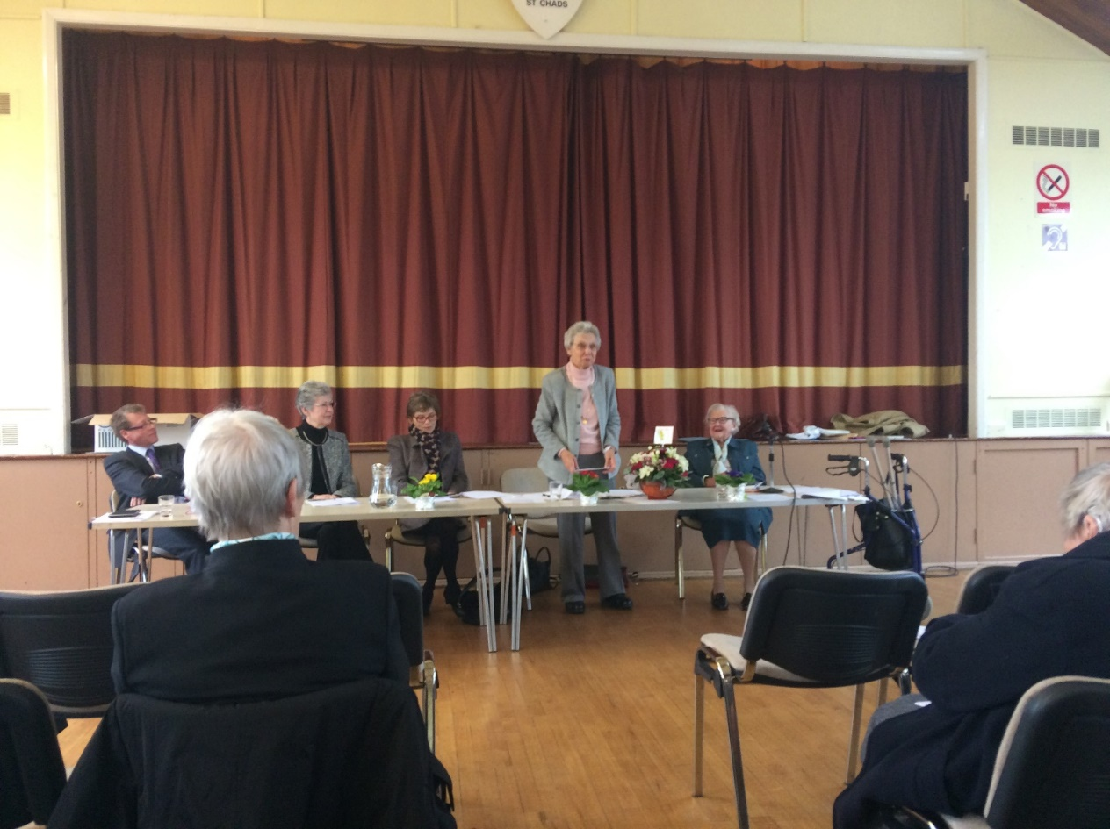

Nancy Donner
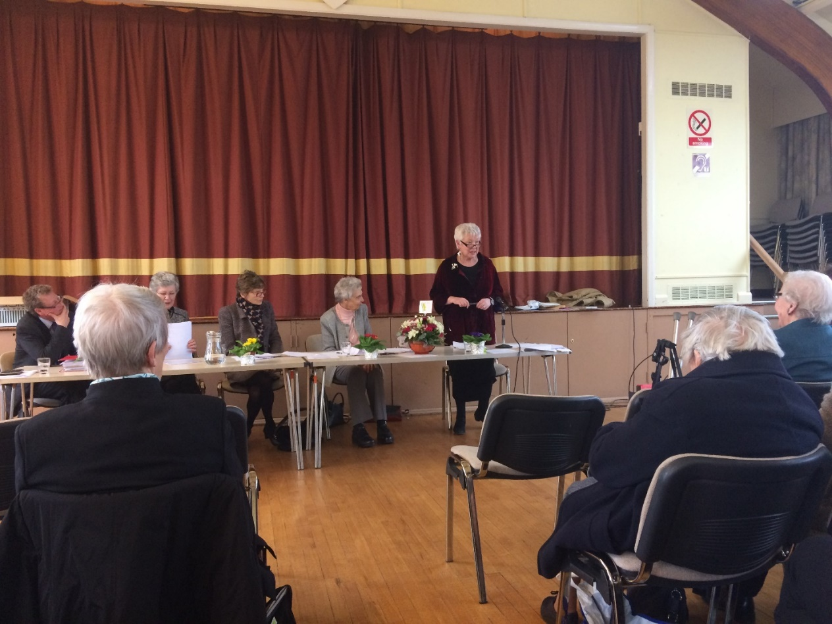

Gill Lydon
THANK YOU

Dear Friends
I want to tell you how much I appreciate the gifts you have given me—not just the beautiful basket of flowers and the very generous cheque at the AGM (I plan to buy something totally self -indulgent!), but also your support over many years and most of all your friendship. Serving you as Chairman has been a great pleasure.
My grateful thanks to you all
Nancy Donner

***GIFT AID***
Everyone needs to read……..
Enclosed with this Newsletter is an updated Gift Aid form. If you haven’t completed one for us before and are eligible for gift aid, please do so as this makes a huge difference to our income. If you have completed one, but it was a long time ago (ie more than 12 months ago), please could you fill in the new form and return it to us. The address is: Phillida Richardson, Ground Floor Office, Forest Hill, Park Crescent, Leeds, LS8 1DH.
Many thanks

SOCIAL COMMITTEE

In November 2015 the Social Committee held their Annual Christmas Food Fayre and Sandwich Lunch at St.Chad’s Parish Centre Headingley.

It was well attended and the Stalls, Seasonal Food all made by the Social Committee, Handbags and Scarves, Jewellery, Phoenix Cards, Seasonal Gifts, Books, were popular and enjoyed. We made £801 and were able to donate £700 to Riding for the Disabled the Leeds Branch, our chosen Charity to support.

In February 2016, the Committee provided the Buffet Lunch for the AGM which was held at St. Chad’s Parish Centre, we received a very kind letter from Margaret Bradbury Secretary of the Executive Committee saying how much everyone had enjoyed the Lunch

This year it was decided to hold the AGM and the Lunch in the Main Hall, this proved to be very successful, and it also meant we did not have to pay for the cost of hiring the small meeting room.

The Social Committee donated £300 to the Awards Committee in March 2016.

The St. Chad’s Parish Centre has been Booked for our Annual Christmas Food Fayre and Sandwich Lunch on Thursday 3rdNovember 2016. Proceeds from this event will be donated to Lineham Farm Children’s Centre Leeds.

Gill Milner

COMMITTEE VACANCIES
We currently have two vacancies within YLCE. The first concerns a Fundraising Committee – we need someone to head up and create the Committee taking responsibility for generating funds for YLCE. The brief is open and, ideally, the candidate will have a range of ideas of ways that will increase the profile of YLCE whilst generating vital income to support the activities of the charity in furthering education.
The second vacancy is that of Newsletter Editor. After doing a sterling job since January 2008, Kim Knowles has decided to step down as our editor. The role requires someone to make sure that events are covered and reported and draw together a magazine twice yearly to keep us all in touch with each other and the developments of YLCE.
If you are interested in any of these roles, know someone who is the perfect candidate, or just want to volunteer as support, please contact Gill Lydon on the contact details at the front of this Newsletter.

MEMBER NEWS
OUR NEW CHAIRMAN
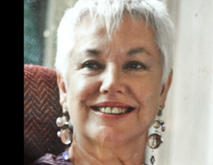

I cannot claim to be a Yorkshire Lady born and bred, though I have lived in Leeds for many years. My husband John and I are both from Barrow-in-Furness, Cumbria and our two sons, Leeds born, occasionally enquire doubtfully what our life was like in the old days, living at the end of a peninsula. Well, we managed! We married after I had completed my first undergraduate year at Liverpool; we spent a year in Pittsburgh then returned to Leeds, where I was first an undergraduate then a postgraduate student in the English department, whilst John became a lecturer in Biophysics.

I taught English briefly in the secondary sector, then worked in adult and higher education, moving on to a lectureship at Leeds College of Music to teach phonetics and some basics of the singing languages to classical singers. I still do a little teaching, some voluntary work, belong to various organisations - and I do love my life in Leeds. One of our sons and his family is still here, the other is in Haslemere (we have 4 grandchildren ranging from 1 year old to 7). I have good friends here and I very much value the fine theatre, concerts, opera, ballet, the excellent market (I try to go Saturday mornings) - and John Lewis still to come! I am enjoying my time on Exec. Long may the YLCE flourish.

Gill
New Members
Mrs Eileen Parkes
Resignations
Mrs Janet Mills

DATES FOR THE DIARY
Visit to Garrowby Hall Wednesday 6 July
Executive Committee Meetings: Monday 30 November - Annual Meeting
Projects Committee Meetings: Monday 18 January 10.00 am
Social Committee Meetings: Thursday 7 January 10.15 am
Social Committee Sandwich lunch Thursday 5 November 11.30 am
Annual General Meeting Monday 1 February

